Rohy v pořádku jen přetočené hrany
# | Diagram | Algoritmus
28 | 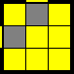 | (M' U M) U2 (M' U M)
57 | 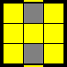 | (R U R' U') (M' U R U') Rw'
20 | 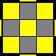 | Rw' (R U) (R U R' U' Rw2) (R2' U) (R U') Rw'

Všechny hrany orientovány

# | Diagram | Algoritmus
23 | 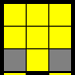 | (R2' D) (R' U2) (R D') (R' U2 R')
24 | 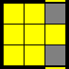 | (Lw' U') (L U) (R U') (Rw' F)
25 | 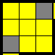 | (R' F) (R B') (R' F') (R B)
27 | 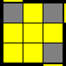 | (R U R' U) (R U2 R')
26 | 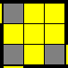 | (R U2) (R' U' R U' R')
22 | 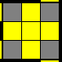 | (R U2') (R2' U') (R2 U') (R2' U2' R)
21 | 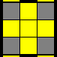 | (R U2) (R' U' R U R' U' R U' R')

Žádná hrana není orientována
# | Diagram | Algoritmus
3 | 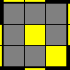 | Fw (R U R' U') Fw' U' F (R U R' U') F'
4 | 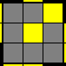 | Fw (R U R' U') Fw' U F (R U R' U') F'
17 | 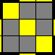 | (R U R' U) (R' F R F') U2 (R' F R F')
19 | 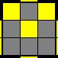 | Rw' (R U) (R U R' U' Rw) x (R2' U) (R U')
18 | 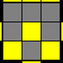 | F (R U R' U) y' (R' U2) (R' F R F')
2 | 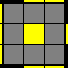 | F (R U R' U') S (R U R' U') Fw'
1 | 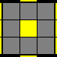 | (R U2) (R2' F R F') U2' (R' F R F')

"T" forma
# | Diagram | Algoritmus
33 | 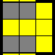 | (R U R' U') (R' F R F')
45 | 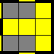 | F (R U R' U') F'

"P" Forma
# | Diagram | Algoritmus
44 | 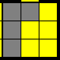 | Fw (R U R' U') Fw'
43 | 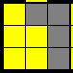 | Fw' (L' U' L U) Fw
32 | 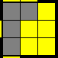 | (R Dw) (L' Dw') (R' U) (Lw U Lw')
31 | 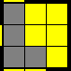 | (R' U') F (U R U' R') F' R

"W" Forma
# | Diagram | Algoritmus
38 | 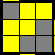 | (R U R' U) (R U' R' U') (R' F R F')
36 | 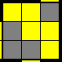 | (L' U' L U') (L' U L U) (L F' L' F)

"malé L" Forma
# | Diagram | Algoritmus
54 | 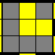 | (Rw U) (R' U) (R U') (R' U) (R U2' Rw')
53 | 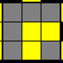 | (Rw' U') (R U') (R' U) (R U') (R' U2 Rw)
50 | 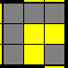 | (R B' R B R2') U2 (F R' F' R)
49 | 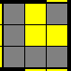 | (R' F R' F' R2) U2 y (R' F R F')
48 | 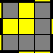 | F (R U R' U') (R U R' U') F'
47 | 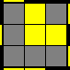 | F' (L' U' L U) (L' U' L U) F

Velké blesky
# | Diagram | Algoritmus
39 | 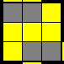 | (L F') (L' U' L U) F U' L'
40 | 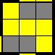 | (R' F) (R U R' U') F' U R

"C" Forma
# | Diagram | Algoritmus
34 | 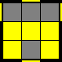 | (R U R2' U') (R' F) (R U) (R U') F'
46 | 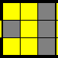 | (R' U') (R' F R F') (U R)

Čtverce
# | Diagram | Algoritmus
5 | 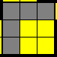 | (Rw' U2) (R U R' U Rw)
6 | 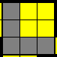 | (Rw U2) (R' U' R U' Rw')

Malé blesky
# | Diagram | Algoritmus
7 | 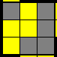 | (Rw U R' U) (R U2 Rw')
12 | 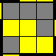 | (M U2) (R' U' R U') (R' U2 R) U M'
8 | 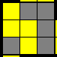 | (Rw' U' R U') (R' U2 Rw)
11 | 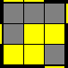 | Rw' (R2 U R' U R U2 R') U M'

Rybičky
# | Diagram | Algoritmus
37 | 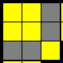 | F (R U') (R' U' R U) (R' F')
35 | 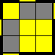 | (R U2) (R2 F) (R F' R U2 R')
10 | 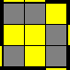 | (R U R' U) (R' F R F') (R U2 R')
9 | 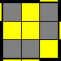 | (R U R' U' R' F) (R2 U R' U' F')

"I" Forma
# | Diagram | Algoritmus
51 | 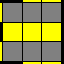 | Fw (R U R' U') (R U R' U') Fw'
52 | 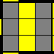 | (R U R' U R Dw') (R U' R' F')
56 | 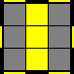 | Fw (R U R' U') Fw' F (R U R' U') (R U R' U') F'
55 | 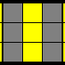 | (R U2) (R2 U' R U' R' U2) (F R F')
„ velké L“ Forma
# | Diagram | Algoritmus
13 | 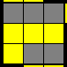 | (Rw U' Rw' U' Rw U Rw' y' (R' U R)
16 | 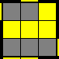 | (Rw U Rw') (R U R' U') (Rw U' Rw')
14 | 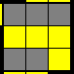 | (R' F) (R U R' F' R) y' (R U' R')
15 | 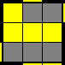 | (Lw' U' Lw) (L' U' L U) (Lw' U Lw)

Hnusné případy
# | Diagram | Algoritmus
41 | 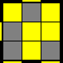 | (R U') (R' U2) (R U) y (R U') (R' U' F')
30 | 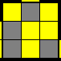 | (R2' U R' B') (R U') (R2' U) (Lw U Lw')
42 | 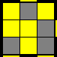 | (L' U) (L U2') (L' U') y' (L' U) (L U F)
29 | 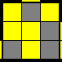 | (L2 U' L B) (L' U) (L2 U') (Rw' U' Rw)

